

**RTI2-Behavior Implementation Manual**

**For**

**Raleigh Egypt Middle School**

**2023 – 2024**

**  **

**RTI2-Behavior Implementation Manual**

**Raleigh Egypt Middle School**

**Shelby County Schools**

**DATE CREATED: September 24, 2019**

**DATE LAST MODIFIED: July 29, 2021**

**2020-2021 TEAM MEMBERS:** Larissa Jackson (Principal), Frederick Thorns, Sonja Thomas, Chalene Hopson, Dauntre’Walker, Patrick Walker, Mary McClain, Tabitha Dean, Tina Simmons, Twilla Callaway, Kameron Moore, Andrea Arredonda



 

****

Contents

[RTI2-B Overview 4](#_Toc31007131)

[Purpose 6](#_Toc31007132)

[Team Composition And Norms 7](#_Toc31007133)

[Student Behavioral Expectations 8](#_Toc31007134)

[School-Wide Behavioral Expectations Matrix 8](#_Toc31007135)

[Lesson Plans 9](#_Toc31007136)

[Teaching The Plan 9](#_Toc31007137)

[Acknowledgement System 13](#_Toc31007138)

[Dealing With Problem Behaviors 14](#_Toc31007139)

[Discipline Process Flowchart 14](#_Toc31007140)

[Minor Incident Report Form (MIR) and Office Disicipline Referral Form (ODR) 15](#_Toc31007141)

[Classroom Checklist 15](#_Toc31007142)

[Planning For Stakeholder Input 15](#_Toc31007143)

[Calendar Of Events 17](#_Toc31007144)

[Evaluation Plan 18](#_Toc31007145)

[Appendix 19](#_Toc31007146)

[Posters 19](#_Toc31007147)

[Expectation Poster 19](#_Toc31007148)

[**School-Wide Behavior Matrix**  20](#_Toc31007149)

[**Posters By Location** 21](#_Toc31007150)

[**Lesson Plans**  28](#_Toc31007151)

[**School-wide Acknowledgement Ticket**  35](#_Toc31007152)

[**Steps To Follow When Addressing Problem Behaviors** 36](#_Toc31007153)

[**Staff-Managed vs. Office Managed Chart**  37](#_Toc31007154)

[**Operational Definitions of Problem Behaviors**  38](#_Toc31007155)

[**Discipline Process Flowchart**  43](#_Toc31007156)

[Minor Incident Report Form (MIR) 44](#_Toc31007157)

[Office Disicipline Referral Form (ODR) 45](#_Toc31007158)

[**Classroom Checklist**  46](#_Toc31007159)

# **RTI2-B Overview**

Response to Instruction and Intervention-Behavior (RTI2-B) is a Multi-Tiered System of Supports (MTSS) that offers a powerful, evidence-based approach for meeting the behavioral and social needs of students in Tennessee schools.

RTI2-B is a promising framework for prevention and intervention within an integrated, three-tiered approach. Each tier of the framework involves careful reflection on the needs of students, the design of interventions matching those needs, and the collection of data to evaluate progress (individually for students and collectively as a school). These efforts require a shared school-wide commitment to teach and reinforce positive behavior. It also involves adopting an optimistic view that all students can learn appropriate behavior if sufficient and supportive opportunities to learn are provided. When using positive behavior supports in all three tiers (e.g., focusing on teaching students the behaviors we want to see, as opposed to punishing the behaviors we don’t want to see, and developing relationships between students and school staff), schools create a culture where all students and teachers are respected and included in their community. Furthermore, student and staff contributions to the school create a positive and proactive way to acknowledge, engage, and respect all stakeholders.

****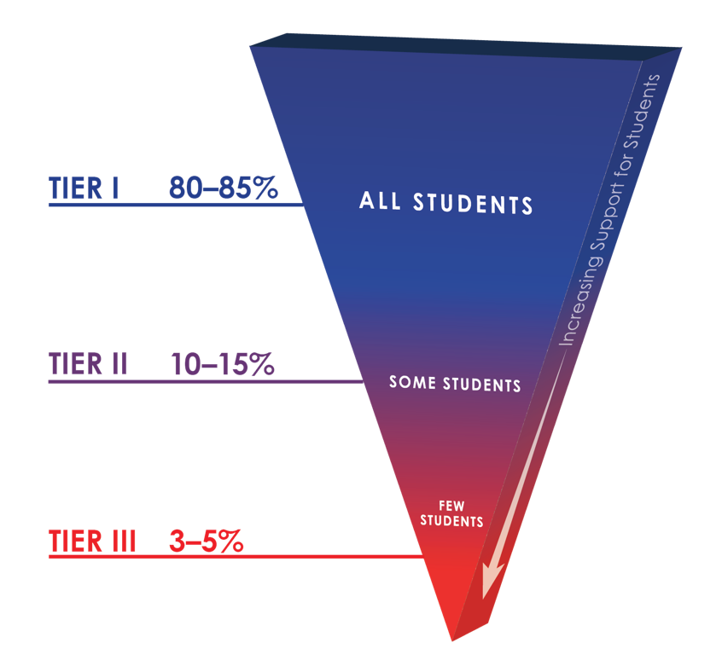The purpose of RTI2-B is to empower educators to equip all students with the opportunity to meet high expectations regarding behavior and the support to reach every student. Also, students, families, and educators can work together to develop and contribute to a shared school vision. Tennessee Behavior Supports Project can help schools meet that goal.

Within the multi-tiered framework of RTI2-B, each tier increases the intensity of intervention and supports so students can be best supported within their school.

Tier I: Tier I focuses on the behavioral and social needs of all students across the school environment. Approximately 80% of students typically respond to this level of support. Tier I includes establishing school-wide expectations to support a sense of safety and inclusion among students and staff, teaching and modeling those expectations within different settings throughout the school, positively acknowledging students and staff who follow these expectations, having a formal system for responding to inappropriate behavior, and maintaining a school-wide system where all stakeholders’ opinions are valued.

Tier II: Tier II involves delivering more targeted interventions for approximately 10-15% of students who do not respond to Tier I supports. Tier II interventions are provided in addition to Tier I supports in place for all students in the school. Interventions at Tier II are typically systematic, evidence-based interventions that are delivered to groups of students at a time. For example, Tier II interventions typically include small-group social skills instruction, behavior contracts, self-monitoring plans, and check-in/check-out.

Tier III: Tier III includes individualized interventions for approximately 3-5% of students who do not respond to Tier I or Tier II interventions and supports. Tier III interventions involve the implementation of specialized, one-on-one systems for students. Examples of Tier III supports include individualized counseling and function-based interventions.

****

# **Purpose**

Raleigh Egypt Middle School’s RTI2-Behavior Leadership Team is committed to the development and support of the social and behavioral climate of our school. The purpose for implementing RTI2-B at our school is

At Raleigh Egypt Middle School, everyone can contribute and everyone can #BeGreat!

In support of our mission, Raleigh Egypt Middle School will implement RTI2-B as a multi-tiered problem solving approach to preventing and reducing problem behaviors while promoting appropriate behaviors, academic engagement, positive school and classroom climates, and positive relationships between students and school staff. We will make good things happen for other people. When things get tough and I fall short, we will remind ourselves we can ACCOMPLISH ANYTHING with time, effort, patience and RESILIENCE. We will Do THE BEST with what we have. We will be resourceful and responsible. We will expect more of ourselves. We will be obligated to this world and the people in it. We will give more and continuously strive to be more. We will BE GREAT!

# 

# **Team Composition And Norms**

The school leadership team for 2021-2022 is listed below. The team will meet monthly to review school data and report findings to the faculty. Faculty and staff are encouraged to contact a team member at any time if there are questions or concerns that need to be addressed at team meetings. Each year up to 50% of team members may roll off as members of the team and new members may be instated. Team member expectations are listed below.

|  |  |  |  |
| --- | --- | --- | --- |
| **RTI2-B School Team** | | | |
| **Name** | **School Role** | **Email** | **Phone Number** |
| **Dione Curry** | **Principal** | **curryd@scsk12.or** | **901-416-4141** |
| **Elnora Chappell** | **School Counselor** | **chappelle@scsk12.org** | **901-416-4141** |
| **Jereme Cade** | **Behavior Interventionist** | **cadej@scsk12.org** | **901-416-4141** |
| **Dauntre’ Walker** | **Functional Skills Teacher** | **Walkerd7@scsk12.org** | **901-416-4141**  **RM 102** |
| **Mary McClain** | **Behavioral Specialist** | [**Mcclainm1@scsk12.org**](mailto:Mcclainm1@scsk12.org) | **901-416-4141 ext. 58133**  **RM 208** |
| **Tina Simmons** | **Family Engagement Specialist** | **simmonst@scsk12.org** | **901-416-4141**  **(Front Office)** |
|  | **Parent Advisor** |  | **901-236-1258** |
| **Mark Awad** | **Student Ambassador** |  |  |
|  | **Student Ambassador** |  |  |
| **Day to meet: 2nd Wednesday of each month** | | **Time: 3:30-4:30** | |
| **Location: Family Engagement Room (A 115 or PLC Room (313)** | | | |
| **Dates to present to staff: 2nd Monday after Fall Break (10/30/2023)** | | | |

|  |
| --- |
| **Proposed Norms for the RTI2-B School Team** |
| * Stick to protocol and hear all voices * Be here now (be present in the moment) * Start and end on time * Assume positive intentions and take responsibility for impact * Ground statement in evidence |

# **Student Behavioral Expectations**

Our school’s agreed-upon behavioral expectations are operationally defined. This will improve clarity and consistency of what is expected throughout the school.

|  |
| --- |
| Raleigh Egypt Middle School’s Behavioral Expectations |
| **C:\Users\JACKSO~1\AppData\Local\Temp\Raleigh-Egypt-Middle_Pharaoh_Head (1).png**School – Wide Expectations:  BE Responsible  BE Respectful  BE Prepared |

Our school designed and created posters to reflect expected behaviors in the school. Posters are displayed throughout the school to prompt students and remind them to follow the expectations. **A picture of the behavioral expectation poster is located in the appendix of this implementation manual.**

# **School-Wide Behavioral Expectations Matrix**

The RTI2-B School-wide matrix anchors expected social skills, in all locations of the school, to the school-wide expectations listed above. Students will no longer guess what is expected of them in each location but will, instead, be taught what is expected and positively acknowledged for following the school-wide expectations and social skills. Posters of the matrix with expectations and social skills will be displayed in designated locations in the building to remind and prompt students to follow the expectations/social skills listed on the matrix. Faculty will have a copy of the matrix in order to remind students of expectations as they transition from one location to the next**. A copy of the matrix is located in the appendix of this implementation manual.**

To further prompt and remind students and teachers of expectations and social skills, posters (for designated locations) will be displayed highlighting the social skills anchored to the expectation for the specific area. **Pictures of these posters are located in the appendix of this manual.**

# **Lesson Plans**

In order to consistently teach the behavioral expectations with social skills in all locations throughout the school, lesson plans have been developed. There is a scripted lesson plan for each location listed on the matrix. Faculty members will be given a schedule at the beginning of each school year that will list when groups of students will be taught the expectations and social skills in each location listed on the matrix. Once lesson plans have been initially taught in each location, teachers will continue to use lesson plans to re-teach and make corrections**. Completed lesson plans are located in the appendix of this implementation manual.**

# 

# **Teaching The Plan**

Our School-wide Leadership Team worked through the logistics of teaching the plan and putting it into place. Details are listed below on how our school will prepare for implementation each year for students, faculty, and family/community. The team has created charts for each group that will be followed each year.

|  |  |  |
| --- | --- | --- |
| **Teaching the Plan to Students** | | |
| **What will be done?** | **How will it be done?** | **When will it be done?** |
| Introduce the plan to students | Students will be gathered in a grade level assembly and introduced to the expectations and reward system | January 6 – 8, 2020 |
| Create and display posters for each setting before students arrive. | A Team member will be asked to hang all posters in designated locations. The matrix will be hung at the entrance of the school and in the office of the person in charge of discipline. Each teacher will be responsible for hanging the classroom poster in their classrooms. Expectation posters will be hung throughout the building. *Posters will be introduced to the students during kickoff.* | Posters will be displayed throughout the building before the students arrive.  Explanation of posters will be given at the kickoff |
| Use lesson plans to teach expected behaviors in all settings. | Each team member will be assigned a location to teach the lesson plan in that location. A schedule will be developed to identify when small groups, with teacher, will go to each location to hear the lesson plan. Teachers will follow-up the lesson plan with planned activities to reinforce the lesson plan. Students will be given practice time and  rewarded for the expectations. | During the first two weeks of second semester. Teachers follow-up will be ongoing. |
| Review the plan and reteach lessons throughout the year. | After each break in school (Fall, Christmas, Spring), the lesson plans will be re-taught to small groups in each location listed on the matrix. Teachers will be responsible for completing this activity. Students will be reward for following the expectations. | After each break in the school year |
| Teach the plan to new students throughout the year. | A student ambassador will be assigned to a new student. The team member will mentor the new student on the process. | Upon arrival of a new student to the building. |
| Establish a STUDENT LEADERSHIP TEAM. | A student leadership team will be identified by grade-level teams. It will consist of a diverse group of students from the upper grades. A leadership team member will facilitate the student team. | As students roll off the team, new members will be added during the Spring to prepare them for the new year. |

|  |  |
| --- | --- |
| **Teaching the Plan to Staff**  **Tentative Dates: December 4-15, 2023** | |
| **Who will be trained on the plan?**  Faculty and staff, resource officers, office staff, paraprofessionals, teachers | |
| **How: PD** | **When: December 4-15, 2023** |
| **How will you train staff to teach expectations and deliver acknowledgements?** | |
| **How:**  Power-points  Reenactment Videos  Realistic Implementation of the plan using teachers that are not meeting expectations | **When: December 4-15, 2023** |
| **How will you teach the components of the discipline process to all staff?**  Behavior definitions, office-managed vs. staff-managed, discipline process flowchart | |
| **How:**  Power-points  Reenactment Videos  Realistic Implementation of the plan using teachers that are not meeting expectations | **When: December 4-15, 2023** |
| **How will you teach core features of the plan to substitute teachers?**  Expectations, acknowledgements, discipline | |
| **How:**  **Copies of expectations in the subfolders** | **When: As needed** |
| **What important dates will you share?** | |
| **How:**  **Dates for school-wide award recognitions** | **When: Quarterly** |

(Adapted from Mid-Atlantic PBIS Tier I Team Implementation Workbook)

|  |
| --- |
| **Teaching the Plan to Family and Community** |
| **How will core features of the plan be shared with family/community members at the beginning of the school year?** |
| Title I Meetings, Student Handbook, Flyers, Parent Teacher Conferences |
| **How often will information about the plan be shared with family/community members?** |
| Semester Title I Meetings  School-Wide Parent-Teacher Conferences  Families Connect Sessions |
| **How can families incorporate RTI2-B in the home?** |
| Set expectations for child’s behavior and stress consequences for misbehavior |
| **What additional resources can family/community members access for more RTI2-B** **information and support?** (e.g., online resources, resources within the district) |
| School’s Website |
| **Who will be the liaison between the school and family/community?** |
| Family Engagement Specialist  Counselors  Parent Ambassadors |
| **How can family/community members get involved with RTI2-B at your school?** |
| PTO  Volunteer (See SCS Guidelines) |
| **Does your school have an established parent organization? If so, who will communicate with the parent organization?** |
| PTO is not organized yet. |

# **Acknowledgement System**

Our RTI2-B Leadership Team investigated several options for positively acknowledging students and faculty; and, family and community. The purpose of the acknowledgement system for students is to promote a positive culture within the building and to encourage and motivate students to be the best they can be. The purpose of the acknowledgement system for faculty, family and community is to show appreciation for their support. The acknowledgement system matrix for each group is below.

As a team, we determined that our school will use wristbands as a part of the acknowledgement system. **A copy of the ticket that will be used is located in the appendix of this manual.**

|  |  |  |  |  |  |  |  |  |  |
| --- | --- | --- | --- | --- | --- | --- | --- | --- | --- |
|  | **School-wide Acknowledgment System Matrix** | | | | | | | | |
|  | Name | | Description | When (frequency) | Where (location) | | Who (distributors) | | |
| **Students** | Phenomenal Pharaoh  Wristbands | Students can receive Phenomenal Pharaoh a wristband when they have perfect attendance (present and on time). | | Weekly | | School-Wide | | Administrators |
| Pharaoh Pride Celebration | Students with 80 class dojo points (behavior)will participate. | | At the end of each quarter | | Site will depend on the event | | RTI2-B Team |
| Students of the Month | Two students per grade level. Recognition will be given via afternoon announcements. Individuals will receive a goody bag. | | At the end of each month | | School-Wide | | Grade Level Teachers |
|  | Artist of the Month | One student will be selected. Recognition will be given via afternoon announcements. Individuals will receive a goody bag. | | At the end of each month | | School-Wide | | Art Teacher |
| **Staff** | Teacher of the Month  Staff of the Month | One teacher per grade level will be recognized.  One staff member will be recognized. | | At the end of each month | | School-Wide | | Administrators |
| Pharaoh Pride Celebration | All teachers with perfect attendance will have lunch. | | Quarterly | | Off-Site Restaurant | | Administrators |
| Persistent Phenomenal Pharaoh Refresher Day | Teachers with perfect attendance will receive additional planning periods/leaving early. | | End of Year after state testing. | | Teachers’ choice | | Administrator |
| **Family/**  **Community** | Pastries for Parents | Parent appreciation  Student showcase | | End of first semester | | School | | Family Engagement Specialist |
| Winter Wonderland | Light refreshments  Vendors  Student performances | | Annually | | For the Kingdom | | Family Engagement Specialist |

# **Dealing With Problem Behaviors**

Our RTI2-B Leadership Team prepared a chart containing operational definitions of problem behaviors showing examples and non-examples to clarify what is considered a minor misbehavior and a major misbehavior. Faculty will refer to this chart to help assist in making decisions regarding the school’s discipline process. **The operational definitions of problem behaviors are located in the appendix of this manual.**

To further clarify what is to be handled in the classroom (minor offense) and what is to be handled in the principal’s office (major offense), the RTI2-B Leadership Team created a chart that list offenses that may be seen in the classroom, handled by the classroom teacher, and offenses that require an immediate trip to the principal’s office. Please note that the teacher managed offenses are not all inclusive. There are minor offenses that may not be listed. It is expected that teachers will use discretion and be consistent. **This chart is located in the appendix of this manual.**

In order to give guidance to teachers on handling minor problem behaviors, **guiding** **steps to follow are located in the appendix of this manual.**

# **Discipline Process Flowchart**

Together as a team, a discipline process flowchart has been created. The flowchart is designed to show steps faculty will take when dealing with behavioral issues and for the major offenses that are sent immediately to principal’s office. It is deemed important that all faculty follow the flowchart to promote consistency in the school environment. **The flowchart is located in the appendix of this manual.**

# **Minor Incident Report Form (MIR) and Office Disicipline Referral Form (ODR)**

Though using the guiding steps to change problem behaviors into good behaviors, it does not always work for all students. With this in mind, the team determined that once a student has reach 5 similar minors with one teacher, the minor then becomes a major and the student is sent to the principal’s office for further discipline. In order to document the minors, the team created a Minor Incident Report form (MIR) so that teachers can track minor behaviors and the principal can document what the teacher has done to try to eliminate the problem. When sending a student with minors to the office, the teacher will include the MIR form along with an office discipline report form (ODR). **The MIR and ODR forms are located in the appendix of this manual.**

# **Classroom Checklist**

Together as a team, in order to insure that all teachers are consistent, a classroom checklist has been created. The checklist will be used to check classrooms to determine how the RTI2-B components are being implemented and if with fidelity. Teachers are encouraged to do self-checks to make sure all components are in place throughout the year. **The classroom checklist is located in the appendix of this manual.**

# **Planning For Stakeholder Input**

Because it is important that our school receive feedback and input from all stakeholders, possible ways were discussed to involve our school community (students, faculty, family/community) in developing the RTI2-B framework. By planning ways to involve them, it is hoped to receive continued input and feedback from them on the components of the RTI2-B framework. The following chart suggest ideas on how our school may receive feedback and input.

|  |  |  |  |  |
| --- | --- | --- | --- | --- |
|  | **Behavioral Expectations** | **Teaching and**  **Re-teaching of Expectations** | **Acknowledgement System** | **Discipline**  **Process** |
| **Students** | Student Leadership Team will review and provide feedback | Different classes will be responsible at quarterly grade-level assemblies to review Behavior Expectations and teach lessons on them | Classes will be surveyed annually to provide ideas for acknowledgements, student leaders will create a Suggestion Box for students to provide input | Have student be part of the discipline process in which student leaders will provide input on how to create student ownership at the school. |
| **Staff** | A draft of the RTI2-B handbook will be sent to faculty and staff for feedback through grade level leads | Lessons will be sent to each grade level lead to be reviewed and suggestions offered before RTI2-B workshop day | A draft of the RTI2-B handbook will be sent to faculty and staff for feedback through grade level leads | All behaviors will be sorted with the staff into office vs. classroom managed during the RTI2-B workshop, team will create definitions, faculty and staff will provide examples and non-examples |
| **Family/**  **Community** | All parts of the plan will be reviewed with family and community during back to school night.  Administrators will ask for feedback from PTO  representative  School will recruit a parent team member for the RTI2-B Leadership team | All parts of the plan will be reviewed with family and community during back to school night.  Administrators will ask for feedback from PTO  representative  School will recruit a parent team member for the RTI2-B Leadership team | All parts of the plan will be reviewed with family and community during back to school night.  Administrators will ask for feedback from PTO  representative  School will recruit a parent team member for the RTI2-B Leadership team | All parts of the plan will be reviewed with family and community during back to school night.  Administrators will ask for feedback from PTO  representative  School will recruit a parent team member for the RTI2-B Leadership team |

# **Calendar Of Events**

Together as a team, RTI2-B calendar components are listed with approximate dates for the school year. At the beginning of each year, the team will add confirmed dates to the school calendar. The approximate dates with components are listed below.

|  |  |
| --- | --- |
| **RTI2-B Calendar Components** | **Date(s)** |
| RTI2-B School Team Meetings | 2nd Wednesday of each month (Jan. 15 – May 20, 2020) |
| Initial Session to Teach Core Components to Staff | October 30, 2023 |
| Booster Sessions to Teach Core Components to Staff | January 8-12, 2023 |
| Begin School-wide Implementation  (e.g., Kick-off Celebration) | January 14, 2023 |
| Teaching Expectation Lesson Plans to Students in All Settings | January 8-12, 2023 |
| Re-teaching Expectation Lesson Plans to Students in All Settings | March 25-28, 2024 |
| Celebrations/Assemblies | Once per Quarter |
| Family Nights | Once per Quarter |
| Other: |  |

# **Evaluation Plan**

Data will be collected and reviewed monthly to identify any weak areas and to make important decisions regarding student behavior. A collection of data will also be used to determine fidelity of the process and teacher satisfaction. The chart below will identify evaluation tools that will be used and when the evaluations will be completed.

|  |  |  |
| --- | --- | --- |
| **Data** | **Evaluation Tool** | **Date to be Completed** |
| **System to collect, organize, and summarize Discipline Data**  (e.g., SWIS, PowerSchool, Infinite Campus) | Our school uses:  Power BI | ***Recommendation:***  Our plan: School based referral form |
| **Fidelity Data** | Tiered Fidelity Inventory (TFI) | ***Recommendation:***  Our plan: Once per semester (December & May) |
| **Social Validity** | Primary Intervention Rating Scale (PIRS)  (Also called the “Staff Input Survey”) | ***Recommendation:***  Our plan: Spring |

# **Appendix**

# **Posters**

# **Expectation Poster**

|  |
| --- |
| Raleigh Egypt Middle School’s Behavioral Expectations |
| **C:\Users\JACKSO~1\AppData\Local\Temp\Raleigh-Egypt-Middle_Pharaoh_Head (1).png**School – Wide Expectations:  BE Responsible  BE Respectful  BE Prepared |

## **School-Wide Behavior Matrix**

|  |  |  |  |  |  |  |  |
| --- | --- | --- | --- | --- | --- | --- | --- |
| **Rules** | **Arrival**  **And Dismissal** | **Classroom** | **Hallway/Locker** | **Cafeteria** | **Restroom** | **Bus** | **Assembly** |
| **BE**  **Respectful** | **-Greet all.**  **-Voice level 1.**  **-Say encouraging and kinds words to others.**  **-Proceed to cafeteria, bus, car, or home.** | **-Follow directions the first time they are given.**  **-Respect others rights to learn.**  **-Raise hand to gain attention.**  **-Stay in assigned seat.**  **-Keep hands, feet and objects to yourself.** | **-Keep hands and feet to self.**  **-Arm’s length from the person in front of you.**  **-Be considerate of yours and others space.**  **-Voice level 1.** | **-Say thank you and please to the workers.**  **-Voice level 0 in serving line.**  **-Wait your turn.**  **-Leave area free of trash.**  **-Voice level 2 while eating.** | **-Follow directions.**  **-Wait your turn.**  **-Use facilities for intended purposes.**  **-Voice level 1.**  **-Give privacy.** | **-Hands and feet to self.**  **-Feet on the floor.**  **-Report problems to bus driver and teacher.**  **-Graffiti free**  **Voice level 1.** | **-Enter and Exit Voice level 0.**  **-Listen and watch at -Voice level 0.**  **-Sit facing front.**  **-Be attentive.**  **-Keep hands and feet to yourself.** |
| **BE Responsible** | **-Be on time daily.**  **-Follow uniform policy.**  **-Walk on the right side of the hallway in a straight line.**  **-Avoid running.**  **-Remain in designated area(s).**  **-Keep movement flowing.** | **-Be on time.**  **-Follow directions.**  **-Turn in homework.**  **-Complete all assignments.**  **-Stay on task.**  **-Watch for voice level cue.** | **-Walk on the right side of the hall in a straight line.**  **-Avoid running.**  **-Valid hall pass**  **-Use hall pass for stated purpose only.**  **-Pick up litter and place in trash bin.** | **-Walk in/out in an orderly manner.**  **-Follow directions the first time given.**  **-Get all items before sitting.**  **-Stay in seat.**  **-Place trash in trash bin.** | **-Complete business in toilet or urinal.**  **-Place tissue in the toilet.**  **-Flush**  **-Wash your hands.**  **-Place trash in trash bin.** | **-Stay in assigned seat.**  **-Keep personal belongings in lap or at feet.**  **-Watch for stop.** | **-Keep feet on floor.**  **-Refrain from eating or drinking.**  **-Graffiti FREE.**  **-Listen and follow expectations.**  **-Voice level 1 when prompted to communicate with others.** |
| **BE**  **Prepared** | **-Proceed to cafeteria after arrival.**  **-Proceed to the designated exit at dismissal.**  **-Bring all needed supplies to school.**  **-Take all needed material home.** | **-Listen carefully.**  **-Pay attention to teachers.**  **-Take notes.**  **-Ask questions.**  **-Participate in class activities.** | **-Follow locker schedule.**  **-Use your assigned locker only.**  **-Enjoy wall art with eyes only.**  **-Keep movement flowing.** | **-Sit in assigned area.**  **-Line up the first time called.**  **-Know your meal code.**  **-Know your lunch choice.**  **-Stay in a straight line.** | **-Take only -necessary materials in the restroom.**  **-One person per stall.**  **-Graffiti free walls.** | **-Greet the driver.**  **-Voice level 1.**  **--Listen to bus driver directions.**  **-Have personal items.** | **-Sit with your grade level.**  **-Raise your hand for permission.**  **-Sit up straight.**  **-Enter the stage on -the right side.**  **-Exit the stage on the left side.** |

### **Posters By Location**

Cafeteria Expectations Poster

**Pharaohs in the Cafeteria Choose to BE:**

|  |  |  |
| --- | --- | --- |
| **Respectful** | **Responsible** | **Prepared** |
| * **Say thank you and please to the workers.** * **Voice level 0 in serving line.** * **Wait your turn.** * **Leave area free of trash.** * **Voice level 2 while eating.** | * **Walk in/out in an orderly manner.** * **Follow directions the first time given.** * **Get all items before sitting.** * **Stay in seat.** * **Place trash in trash bin.** | * **Sit in assigned area.** * **Line up the first time called.** * **Know your meal code.** * **Know your lunch choice** * **Stay in a straight line.** |

**Voice Levels: 0 = Silence 1 = Whisper 2 = Small Group 3 = Presenting 4 = Outside**

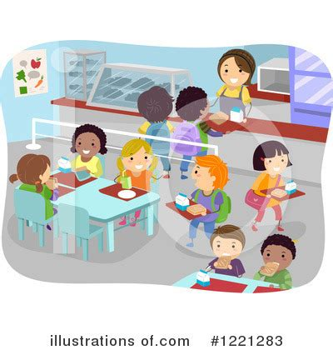

**Restroom Expectations Poster**

**Pharaohs in the Restroom Choose to BE:**

|  |  |  |
| --- | --- | --- |
| **Respectful** | **Responsible** | **Prepared** |
| * **Follow directions.** * **Wait your turn.** * **Use facilities for intended purposes.** * **Voice level 1.** * **Give privacy.** | * **Complete business in toilet or urinal.** * **Place tissue in the toilet.** * **Flush** * **Wash your hands.** * **Place trash in trash bin.** | * **Take only necessary materials in the restroom.** * **One person per stall.** * **Graffiti free walls.** |

**Voice Levels: 0 = Silence 1 = Whisper 2 = Small Group 3 = Presenting 4 = Outside**

**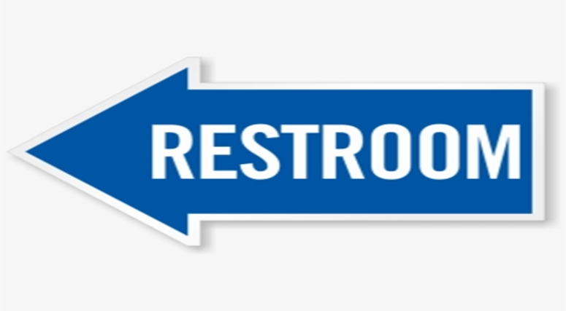**

**Hallway/Locker Expectations Poster**

**Pharaohs in the Hallway/Locker Choose to BE:**

|  |  |  |
| --- | --- | --- |
| **Respectful** | **Responsible** | **Prepared** |
| * **Keep hands and feet to self.** * **Arm’s length from the person in front of you.** * **Be considerate of yours and others space.** * **Voice level 1.** | * **Walk on the right side of the hall in a straight line.** * **Avoid running.** * **Valid hall pass** * **Use hall pass for stated purpose only** * **Pick up litter and place in trash bin** | * **Follow locker schedule** * **Used your assigned locker only** * **Keep movement flowing.** * **Enjoy wall art with eyes only.** |

**Voice Levels: 0 = Silence 1 = Whisper 2 = Small Group 3 = Presenting 4 = Outside**

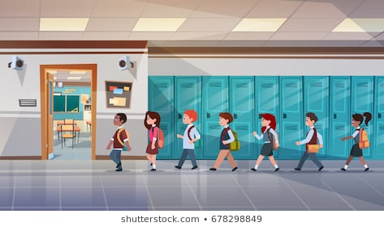

Arrival & Dismissal Expectations Poster

**Pharaohs during Arrival & Dismissal Choose to BE:**

|  |  |  |
| --- | --- | --- |
| **Respectful** | **Responsible** | **Prepared** |
| * **Greet all.** * **Say encouraging and kinds words to others.** * **Voice level 1** * **Proceed to cafeteria, bus, car, or home** | * **Follow uniform policy.** * **Walk on the right side of the hallway in a straight line.** * **Avoid running.** * **Remain in designated area(s)** * **Keep movement**   **flowing in the hallway.** | * **Proceed to the cafeteria after arrival** * **Proceed to the designated exit at dismissal** * **Bring all needed material to school.** * **Take all needed material home.** * **Adhere to arrival and dismissal time** * **Dismiss when called over the intercom** |

**Voice Levels: 0 = Silence 1 = Whisper 2 = Small Group 3 = Presenting 4 = Outside**

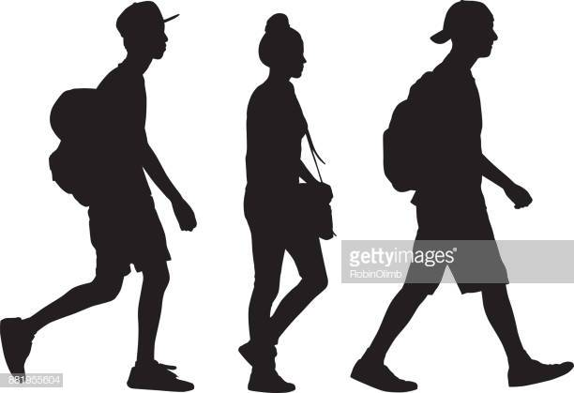

Classroom Expectations Poster

**Pharaohs in the Classroom BE**:

|  |  |  |
| --- | --- | --- |
| **Respectful** | **Responsible** | **Ready** |
| * **Follow directions the first time they are given.** * **Respect others rights to learn.** * **Raise hand to gain attention.** * **Stay in assigned seat.** * **Keep hands, feet and objects to yourself.** | * **Be on time.** * **Follow directions.** * **Complete all assignments.** * **Turn in homework** * **Stay on task.** * **Watch for voice level cue.** | * **Wear your uniform daily** * **Bring supplies daily.** * **Listen carefully.** * **Pay attention to teachers.** * **Take notes.** * **Ask questions.** * **Participate in class activities.** |

**Voice Levels: 0 = Silence 1 = Whisper 2 = Small Group 3 = Presenting 4 = Outside**

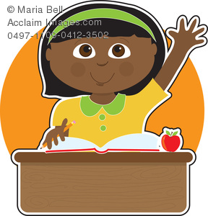

Assembly Expectations Poster

**Pharaohs in the Assembly Choose to BE:**

|  |  |  |
| --- | --- | --- |
| **Respectful** | **Responsible** | **Ready** |
| * **Enter and Exit at Voice Level 0** * **Listen and Watch at Voice level 0** * **Sit facing front** * **Be attentive.** * **Keep hands and feet to yourself.** | * **Keep feet on floor** * **Refrain from eating or drinking** * **Graffiti FREE** * **Listen and follow expectations.** * **Voice level 1 when prompted to communicate with others.** | * **Sit with grade level** * **Raise hand for permission** * **Sit up straight.** * **Enter the stage on the right side.** * **Exit the stage on the left side.** |

**Voice Levels: 0 = Silence 1 = Whisper 2 = Small Group 3 = Presenting 4 = Outside**

***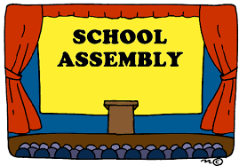***

Bus Expectations Poster

**Pharaohs on the Bus Choose to BE:**

|  |  |  |
| --- | --- | --- |
| **Respectful** | **Responsible** | **Ready** |
| * **Hands and feet to self.** * **Feet on the floor.** * **Report problems to bus driver and teacher.** * **Graffiti free.** * **Voice level 1.** | * **Stay in assigned seat.** * **Keep personal belongings in lap or at feet.** * **Watch for your stop.** | * **Greet the driver.** * **Voice level 1.** * **Listen to bus driver directions.** * **Have personal items.** |

**Voice Levels: 0 = Silence 1 = Whisper 2 = Small Group 3 = Presenting 4 = Outside**

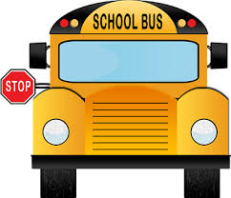

## **Lesson Plans**

**Raleigh Egypt Middle**

**School-wide Expectations Lesson Plan: Arrival/Dismissal**

Lesson plans should be taught in the area and take 10-15 minutes

|  |  |
| --- | --- |
| **Objective** | The students will be able to enter and exit the building calmly, in a respectful, responsible, and prepared manner. |
| **Setting** | Arrival and Dismissal (includes hallways, sidewalks, parking lots) |
| **Expectations** | *(refer to Behavioral Expectations Matrix)*  **Respectful:** Greet all. Voice level 1. Say encouraging and kinds words to others.  **Responsible:** Be on time. Go directly to destination.  **Prepared:** Be prepared for class. Take all needed material home. Keep movement flowing in the hallway. |
| **Examples:**  **Teach using “I Do, we do, you do”** | 1. Students will wait at the curb for cars to fully stop before moving off of the curb. 2. Students will wait for a cross walk attendant to signal safe and appropriate crossing time. 3. Students will keep their bodies to self while waiting with a calm, quiet body for the school to open. |
| **Non-Examples: Model Only** | 1. Running off the bus with an out-of-control body (e.g., flailing arms, shouting, running, etc.). 2. Not using cross-walks and crossing between cars. 3. Jumping on/over the half-wall in the front of the building. |
| **Follow Through and Practice** | 1. Practice and model appropriate behavior while entering and exiting the building. 2. Create school-wide videos that demonstrate appropriate behavior and expectations. 3. Practice with the crossing guard signal and signs so students know when they are permitted to cross at the cross-walk. |
| **Reinforcement: How will behaviors be reinforced in this setting** | 1. Students with no infractions will be able to participate in grade-level/school-wide celebrations. 2. Put a student in a “teacher role” to help reinforce and model expectations. |

**Raleigh Egypt Middle**

**School-wide Expectations Lesson Plan: Assemblies & Special Events**

Lesson plans should be taught in the area and take 10-15 minutes

|  |  |
| --- | --- |
| **Objective** | The students will be able to be a respectful, responsible, and prepared audience behavior in assemblies and special events. |
| **Setting** | Assemblies and Special Events (typically held in the gym or cafeteria) |
| **Expectations** | *(Refer to Behavioral Expectations Matrix)*  **Respectful:** Voice level 0 (entrance & exit). Follow directions the first time they are given. Be attentive. Keep hands and feet to yourself.  **Responsible:** Listen and follow expectations. Voice level 1 when prompted to communicate with others.  **Prepared:** Sit up straight. Enter the stage on the right side. Exit the stage on the left side. |
| **Examples:**  **Teach using “I Do, we do, you do”** | 1. Sitting on bottom 2. Voices off 3. 4As of Audience |
| **Non-Examples: Model Only** | 1. Talking to your neighbor 2. Sitting up on knees or feet |
| **Follow Through and Practice** | 1. Pretend you’re in an assembly. Show me what you would do (try this during P.E. while teaching a game in the gym, or other setting you deem appropriate). 2. Find and use a video of an audience. Have your class critique their audience behavior. 3. Practice audience behavior during classroom presentations, or student share outs.   *\*Practice signals to use:* Give me 5; Hand Up, Voices Off |
| **Reinforcement: How will behaviors be reinforced in this setting** | 1. Students with no infractions will be able to participate in grade-level/school-wide celebrations. |

**Raleigh Egypt Middle School**

**School-wide Expectations Lesson Plan: School Bus**

Lesson plans should be taught in the area and take 10-15 minutes

|  |  |
| --- | --- |
| **Objective** | The students will show respectful, responsible and prepared behaviors so they can arrive at school on time and in a safe manner. |
| **Setting** | School Bus |
| **Expectations** | *(Refer to Behavioral Expectations Matrix)*  **Respectful:** Hands and feet to self. Feet on the floor. Report problems to bus driver and teacher. Graffiti free. Voice level 1.  **Responsible:** Stay in assigned seat. Keep personal belongings in lap or at feet.  Watch for stop.  **Prepared:** Greet the driver. Voice level 1. Listen to bus driver directions. Have personal items**.** |
| **Examples:**  **Teach using “I Do, we do, you do”** | 1. Keeping hands, objects, and body to self 2. Bottom to bottom, back to back 3. Conversational voice level |
| **Non-Examples: Model Only** | 1. Arguing/fighting over seats (e.g., yelling, shouting, pushing, hitting, etc.) 2. Using inappropriate language (e.g., cursing, calling each other names that are hurtful or offensive, etc.) |
| **Follow Through and Practice** | 1. Set up classroom chairs to mimic school bus benches. Practice walking on bus. Have students load from back to front. 2. Use classroom lights as a signal to practice voices on and off.   *\*Practice signals to use:* “Peace Sign” means silent voice. |
| **Reinforcement: How will behaviors be reinforced in this setting** | 1. Students with no infractions will be able to participate in grade-level/school-wide celebrations. |

**Raleigh Egypt Middle School**

**School-wide Expectations Lesson Plan: Cafeteria**

Lesson plans should be taught in the area and take 10-15 minutes

|  |  |
| --- | --- |
| **Objective** | The students will be exhibit respectful, responsible, and prepared behavior in the cafeteria. |
| **Setting** | Cafeteria |
| **Expectations** | **Respectful:** Say thank you and please to the workers. Voice level 0 in serving line. Wait your turn. Leave area free of trash. Voice level 2 while eating.  **Responsible:** Walk in/out in an orderly manner. Follow directions the first time given. Get all items before sitting. Stay in seat. Place trash in trash bin.  **Prepared:** Sit in assigned area. Line up the first time called. Know your meal code. Know your lunch choice. Stay in a straight line. |
| **Examples:**  **Teach using “I Do, we do, you do”** | 1. One student holds a tray to go to the table using an inside voice and demonstrates how to dump tray. 2. Student stands in the food line correctly (space between bodies, facing forward). 3. Using polite table manners. 4. Clean up after self. 5. Raise hand to leave assigned area. |
| **Non-Examples: Model Only** | 1. Pushing in line 2. Making a mess (e.g., food and trash on floor or table, and not on tray) and not cleaning up after self 3. Not using polite manners (e.g., loud talking, playing with food, shoving food in mouth, eating and talking at the same time, etc.) |
| **Follow Through and Practice** | 1. Video of positive cafeteria behavior 2. Put weekly cafeteria objective on white board in the cafeteria.   *\*Practice signals to use:* Follow signal of cafeteria supervisor; Follow signal for dismissal |
| **Reinforcement: How will behaviors be reinforced in this setting** | 1. Students with no infractions will be able to participate in grade-level/school-wide celebrations. |

**Raleigh Egypt Middle School**

**School-wide Expectations Lesson Plan: Classroom**

Lesson plans should be taught in the area and take 10-15 minutes

|  |  |
| --- | --- |
| **Objective** | The students will use respectful, responsible, and prepared behaviors when in the classroom setting and during all classroom routines. |
| **Setting** | Grade-Level Classrooms and Related Arts Classrooms |
| **Expectations** | *(Refer to Behavioral Expectations Matrix)*  **Respectful:** Follow directions the first time they are given. Respect others rights to learn. Raise hand to gain attention. Stay in assigned seat. When leaving table, push chair under table.  **Responsible:** Be on time. Follow directions. Complete all assignments. Stay on task. Watch for voice level cue.  **Be Prepared:** Bring supplies daily. Listen carefully. Pay attention to teachers. Take notes. Ask questions. Participate in class activities. |
| **Examples:**  **Teach using “I Do, we do, you do”** | 1. Students put materials away in desk upon teacher’s signal and walk to the rug at the front of the room. 2. Students use walking feet and line up single file at the door. 3. Eyes on teacher with a quiet mouth when teacher is talking. 4. Soliciting teacher assistance by raising hand without talking and waiting for teacher. |
| **Non-Examples: Model Only** | 1. Running in the classroom 2. Interrupting teacher while teacher is talking 3. Pushing peers while standing in line. |
| **Follow Through and Practice** | 1. Teacher gives a hand signal to indicate it’s time for quiet voices and listening ears. Students practice turning their voices off when the teacher gives the hand signal. Teacher provides feedback and behavior-specific praise. 2. Teacher uses an auditory or visual signal (e.g., lights on and off, visual timer, etc.) to indicate it’s time to transition between centers. Students practice cleaning up and transitioning to their next center. Teacher provides feedback and behavior-specific praise. 3. Students brainstorm what safe, respectful, and responsible behaviors look like in the classroom. They role-play those behaviors and provide feedback to each other. Teacher models non-examples.   *\*Practice signals to use:* Hand signals, timer/visual signals |
| **Reinforcement: How will behaviors be reinforced in this setting** | 1. Students with no infractions will be able to participate in grade-level/school-wide celebrations. |

**Raleigh Egypt Middle**

**School-wide Expectations Lesson Plan: Hallways**

Lesson plans should be taught in the area and take 10-15 minutes

|  |  |
| --- | --- |
| **Objective** | The students will follow the expectations to be respectful, responsible, and prepared in the hallways and commons. |
| **Setting** | Hallways |
| **Expectations** | *(Refer to Behavioral Expectations Matrix)*  **Respectful:** Keep hands and feet to self. Arm’s length from the person in front of you. Be considerate of yours and others space. Voice level 1.  **Responsible:** Follow directions the first time. Walk on the right side of the hall in a straight line. Avoid running.  **Prepared:** Display your hall pass. Enjoy wall art with eyes only. Keep movement flowing. |
| **Examples:**  **Teach using “I Do, we do, you do”** | 1. H – hands to side/self 2. A – all eyes forward 3. L – lips sealed 4. L – legs walking with the group 5. S – single file |
| **Non-Examples: Model Only** | 1. Hands on people or on walls 2. Looking to the side or head turned to look backwards 3. Talking, whistling, humming 4. Walking too slowly (i.e., not staying with the group), walking too quickly (i.e., getting ahead of the group), running, creating a gap, walking backwards 5. Walking beside someone |
| **Follow Through and Practice** | 1. Repeated practice of walking and waiting in the hallways   *\*Practice signals to use:* Gesture given by teacher for silent voice; sign with pictures/sign language (if needed) |
| **Reinforcement: How will behaviors be reinforced in this setting** | 1. Students with no infractions will be able to participate in grade-level/school-wide celebrations. |

**Raleigh Egypt Middle School**

**School-wide Expectations Lesson Plan: Restroom**

Lesson plans should be taught in the area and take 10-15 minutes

|  |  |
| --- | --- |
| **Objective** | The students will be able to use the bathrooms in a safe, respectful, and responsible manner. |
| **Setting** | Restrooms |
| **Expectations** | *(Refer to Behavioral Expectations Matrix)*  **Respectful:** Follow directions. Wait your turn. Use facilities for intended purposes. Voice level 1. Give privacy.  **Responsible**: Complete business in toilet or urinal. Place tissue in the toilet. Flush. Wash your hands. Place trash in trash bin.  **Prepared:** Take only necessary materials in the restroom. One person per stall.  Graffiti free walls. |
| **Examples:**  **Teach using “I Do, we do, you do”** | 1. Joe uses the restroom and washes his hands. 2. Macy is in the restroom and sees her friends and says “Hi” but leaves quickly and walks back to class. 3. Abby walks in the restroom and sees someone throwing paper towels around. She asks them to stop and walks away calmly to report the situation to an adult. |
| **Non-Examples: Model Only** | 1. Two students are in the restroom singing in a loud voice. 2. Student is splashing water onto the floor from the sink. |
| **Follow Through and Practice** | 1. Videos of proper restroom usage to show to class for discussion/review. 2. Videos of non-examples. Classrooms watch, and students are instructed to raise hands when they notice someone NOT following expectations. |
| **Reinforcement: How will behaviors be reinforced in this setting** | 1. Students with no infractions will be able to participate in grade-level/school-wide celebrations. |

## **School-wide Acknowledgement Ticket**

[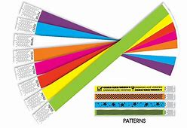](https://www.bing.com/images/search?view=detailV2&ccid=0YohjzrB&id=D63DF1D219BB27C38B70DD90D63D3D7858010C7B&thid=OIP.0YohjzrBekcXVWEZqjpNAAHaFE&mediaurl=https://printingspecialists.co.za/wp-content/uploads/2017/12/wrist-bands-01.jpg&exph=702&expw=1026&q=picture+of+wristbands+with+adhesion&simid=608054561111214630&selectedIndex=196)

[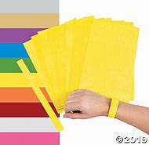](https://www.bing.com/images/search?view=detailV2&ccid=PvVDLzMN&id=88AE0A64218153257CF0BC52134C463F714A96CE&thid=OIP.PvVDLzMNnkpDcAMCEJYfQQAAAA&mediaurl=http://s7.orientaltrading.com/is/image/OrientalTrading/VIEWER_IMAGE_400/self-adhesive-wristbands~13762505&exph=400&expw=400&q=picture+of+wristbands+with+adhesion&simid=608000921275793608&selectedIndex=73)

## **Steps To Follow When Addressing Problem Behaviors**

Responses To Inappropriate Behaviors Are Always:

* Calm
* Consistent
* Brief
* Immediate
* Respectful

Steps To Specific Error Correction:

* Respectfully address the student
* Describe inappropriate behavior
* Describe expected behavior/expectation
* Anchor to expectation on Matrix
* Redirect back to appropriate behavior

Preventive strategies to discourage problem behavior

* Active supervision
* Pre-corrects
* Increased praise

|  |  |  |
| --- | --- | --- |
|  | **ACTIVE SUPERVISION** | **PRE-CORRECTS** |
| **What is it?** | Moving, scanning, and positively interacting with students | A general reminder preceding the context in which the behavior is expected |
| **Why?** | Sets students up for success and reminds teacher to watch for desired behaviors | Provides students with a reminder to increase the probability of their success |

## **Staff-Managed vs. Office Managed Chart**

The following clarifies behaviors that will be handled by the school office and by the teacher.

|  |  |
| --- | --- |
| **Office-Managed Problem Behavior** | **Staff-Managed Problem Behavior** |
| Weapons  Fighting or Aggressive Physical Contact  Chronic Minor Infractions  Aggressive Language  Threats/Bullying  Harassment/Foul Language of Student or Teacher  Truancy/Cut Class  Smoking  Vandalism  Alcohol Drugs  Gambling  Dress Code  Cheating  Leaving School Grounds  Not w/Class During Emergency | Preparedness  Absenteeism/tardy to class  Calling Out  Classroom Disruption  Refusal to Follow a Reasonable Request (Insubordination)  Failure to Serve a Detention  Put Downs  Inattentiveness  Refusing to Work  Inappropriate Tone/Attitude  Electronic Devices  Inappropriate Comments  Food or Drink |

## **Operational Definitions of Problem Behaviors**

| **Minor Problem Behavior** | **Definition** | **Example** | **Non-examples** |
| --- | --- | --- | --- |
| Defiance/Disrespect/ Non-compliance  (M-Disrespect) | Student engages in brief or low-intensity failure to respond to adult requests. | Talking back, not following directions, sleeping, ignoring teacher, refusal to complete assignment |  |
| Disruption  (M-Disruption) | Student engages in low-intensity, but inappropriate disruption. | Intentional distractions, noises, pranks, annoying statements/questions, breaking line, making messes, throwing paper wads, tapping pencil, out or seat, passing gas |  |
| Dress Code  Violation  (M-Dress) | Student wears clothing that is near, but not within, the dress code guidelines defined by the school/district. | Shirt untucked, no belt |  |
| Inappropriate Language  (M-Inapp Lan) | Student engages in low-intensity instance of inappropriate language. | Put downs, taunts, or slurs of a non-offensive nature, saying stupid, ugly, shut up, etc., |  |
| Other  (M-Other) | Student engages in any other minor problem behaviors that do not fall within the above categories. |  |  |
| Physical Contact/ Physical Aggression  (M-Contact) | Student engages in non-serious, but inappropriate physical contact. | Horse play, playful grabbing, pinching, non-aggressive punching or slapping, chasing, shoving. “not keeping hands and feet to self.” |  |
| Property Misuse  (M-Prpty Misuse) | Student engages in low-intensity misuse of property. | Breaking pencils/crayons, kicking furniture, mishandling textbooks/library books/tearing up paper/assignments, handouts, slamming locker |  |
| Tardy  (M-Tardy) | Student arrives at class after the bell (or signal that class has started). | Students enters classroom after bell rings without excuse or an admit slip |  |
| Technology Violation  (M-Tech) | Student engages in non-serious but inappropriate (as defined by school) use of cell phone, pager, music/video players, camera, and/or computer. | Using computer time inappropriately, possessing electronic devices without permission |  |
| Taunting/teasing | Inappropriate comments and/or unwanted verbal, physical, or emotional advances | Making faces, calling other students names such as gay, fag, retard, whore, or pimp without the receiver felling uncomfortable or threatened |  |
| Profanity | Inappropriate language, cursing | Inappropriate language or curse word not directed at anyone specifically |  |
| Name calling | Use of disrespectful, hurtful language | Putdowns, taunts, or slurs of a non-offensive nature, mild oaths not directed at an individual. Offensive communications targeting race, gender, faith, etc. of others. |  |

| **Major Problem Behavior** | **Definition** | **Example** | **Non-example** |
| --- | --- | --- | --- |
| Abusive Language/ Inappropriate Language/ Profanity  (Inapp Lan) | Student delivers verbal messages that include swearing, name calling or use of words in an inappropriate way. | Cursing, slandering another person, hostile threats either written, spoken, or non-verbal | Put downs, taunts, or slurs of a non-offensive nature, saying stupid, ugly, shut up, etc., mild oaths not directed at an individual. Offensive communications targeting race, gender, faith, etc. of others. |
| Arson  (Arson) | Student plans and/or participates in malicious burning of property. | Setting fires to or on school property. Possession of combustible items | Student is carrying a lighter |
| Bomb Threat/  False Alarm  (Bomb) | Student delivers a message of possible explosive materials being on-campus, near campus, and/or pending explosion. | Written or verbal bomb threat, deliberately pulling fire alarm when not warranted, planting an explosive device on school grounds/property, making or attempting to construct a bomb at school |  |
| Defiance/Disrespect/ Insubordination/  Non-Compliance  (Disrespect) | Student engages in refusal to follow directions, talks back and/or delivers socially rude interactions. | Refusing to comply with rules/expectations, leaving class without permission, verbal defiance/ argumentative | Mildly talking back, not following directions, sleeping, ignoring teacher, refusal to complete assignment |
| Disruption  (Disruption) | Student engages in behavior causing an interruption in a class or activity. Disruption includes sustained loud talk, yelling, or screaming; noise with materials; horseplay or roughhousing; and/or sustained out-of-seat behavior. | Screaming, loud talk, fighting. Any behavior more than nagging that impedes the educational environment | Intentional distractions, noises, pranks, annoying statements/questions, breaking line, making messes, throwing paper wads, tapping pencil, out or seat, passing gas |
| Dress Code Violation  (Dress) | Student wears clothing that does not fit within the dress code guidelines practiced by the school/district. | Wearing something other than what dress code dictates | Shirt untucked, no belt |
| Fighting  (Fight) | Student is involved in mutual participation in an incident involving physical violence. | Hitting with intent to hurt, punching, kicking, hair pulling, scratching, choking | Horse play, playful grabbing, pinching, non-aggressive punching or slapping, chasing, shoving. “not keeping hands and feet to self.” |
| Forgery/ Theft  (Forge/Theft) | Student is in possession of, having passed on, or being responsible for removing someone else's property or has signed a person’s name without that person’s permission. | Forged notes from parents, doctors, teacher, etc.  Stealing, hiding/purchasing stolen property, aiding someone in stealing |  |
| Gang Affiliation Display  (Gang Display) | Student uses gesture, dress, and/or speech to display affiliation with a gang. |  |  |
| Harassment/Bullying  (Harass) | Student delivers disrespectful messages\* (verbal or gestural) to another person that includes threats and intimidation, obscene gestures, pictures, or written notes.  *\*Disrespectful messages include negative comments based on race, religion, gender, age, and/or national origin; sustained or intense verbal attacks based on ethnic origin, disabilities or other personal matters.* | Repeated verbal harassment or abuse, inappropriate touching, gesturing, notes or pictures |  |
| Inappropriate Display of Affection  (Inapp affection) | Student engages in inappropriate, consensual (as defined by school) verbal and/or physical gestures/contact, of a sexual nature to another student/adult. | Inappropriate contact with another student or adult | Students give a brief hug of friendship |
| Inappropriate Location/ Out of Bounds Area  (Out Bounds) | Student is in an area that is outside of school boundaries (as defined by school). | Caught in inappropriate area of school property | Student in restroom without a pass |
| Lying/Cheating  (Lying) | Student delivers message that is untrue and/or deliberately violates rules. | Forged notes from parents, doctors, teachers. Takes someone else’s work and claims it to be their own | Student makes up story regarding homework or not have appropriate materials |
| Other Behavior  (Other) | Student engages in problem behavior not listed. |  |  |
| Physical Aggression  (PAgg) | Student engages in actions involving serious physical contact where injury may occur (e.g., hitting, punching, hitting with an object, kicking, hair pulling, scratching, etc.). | Fighting with the intent to hurt | horseplay |
| Property Damage/Vandalism  (Prop dam) | Student participates in an activity that results in destruction or disfigurement of property. | Purposely breaking classroom materials, throwing desks, chairs, computers, destruction of any school property |  |
| Skip class  (Skip) | Student leaves or misses class without permission. |  |  |
| Truancy  (Truan) | Student receives an ‘unexcused absence’ for ½ day or more. |  |  |
| Tardy  (Tardy) | Student is late (as defined by the school) to class or the startup of the school day (and Tardy is not considered a minor problem behavior in the school). | Student enters class **after bell** | Student is in the door when the bell rings |
| Technology Violation  (Tech) | Student engages in inappropriate (as defined by school) use of cell phone, pager, music/video players, camera, and/or computer. | Has cell phone or another inappropriate device visible | Devices are properly stored, but not turned to silence |
| Use/Possession of Alcohol  (Alcohol) | Student is in possession of or is using alcohol. | Smelling of alcohol, possession of alcohol |  |
| Use/Possession of Combustibles  (Combust) | Student is in possession of substances/objects readily capable of causing bodily harm and/or property damage (matches, lighters, firecrackers, gasoline, lighter fluid). | Has possession of |  |
| Use/Possession of Drugs  (Drugs) | Student is in possession of or is using illegal drugs/substances or imitations. | Has possession of |  |
| Use/Possession of Tobacco  (Tobacco) | Student is in possession of or is using tobacco. | Has possession of |  |
| Use/Possession of Weapons  (Weapons) | Student is in possession of knives or guns (real or look alike), or other objects readily capable of causing bodily harm. | Has possession of |  |

## **Discipline Process Flowchart**

**BEHAVIORAL INCIDENT FLOWCHART (BIF)**

**Emailed Separately (PDF only)**

# **Minor Incident Report Form (MIR)**

|  |  |  |
| --- | --- | --- |
| **1st Incident** | **Date** | **Time** |
| **Location** | **Problem Behavior** | **Staff Intervention/Action Taken** |
| Classroom  Cafeteria  Gym  Corridor  Locker Room  Outside Building/Playground  Restroom  Other: \_\_\_\_\_\_\_\_\_\_\_\_\_\_ | Disruption: Excessive talking, argumentative.  Dress Code Violation  Horseplay  Profanity/Inappropriate Language  Non-Compliance: Class rules, cheating, cell phone, off task  **Student Signature**: \_\_\_\_\_\_\_\_\_\_\_\_\_\_\_\_\_\_\_\_\_\_\_\_\_\_\_\_\_\_\_\_\_\_\_\_\_\_\_ | Warning/Retaught Expectation  Contact Parent via  Email: \_\_\_\_\_\_\_\_\_\_\_\_\_\_\_  Phone: \_\_\_\_\_\_\_\_\_\_\_\_\_\_  Note Home Date: \_\_\_\_\_\_\_\_  Parent Conf Date: \_\_\_\_\_\_\_\_  Lunch Detention: \_\_\_\_\_\_\_\_\_\_\_\_\_\_\_\_\_\_  Seat Change/Student Conference  Other: \_\_\_\_\_\_\_\_\_\_\_\_\_\_\_\_\_\_\_\_\_\_\_\_\_\_\_\_  **Teacher Initials:** \_\_\_\_\_\_\_\_\_\_\_\_\_\_ |
| **2nd Incident** | **Date** | **Time** |
| **Location** | **Problem Behavior** | **Staff Intervention/Action Taken** |
| Classroom  Cafeteria  Gym  Corridor  Locker Room  Outside Building/Playground  Restroom  Other: \_\_\_\_\_\_\_\_\_\_\_\_\_\_ | Disruption: Excessive talking, argumentative.  Dress Code Violation  Horseplay  Profanity/Inappropriate Language  Non-Compliance: Class rules, cheating, cell phone, off task  **Student Signature**: \_\_\_\_\_\_\_\_\_\_\_\_\_\_\_\_\_\_\_\_\_\_\_\_\_\_\_\_\_\_\_\_\_\_\_\_\_\_\_ | Warning/Retaught Expectation  Contact Parent via  Email: \_\_\_\_\_\_\_\_\_\_\_\_\_\_\_  Phone: \_\_\_\_\_\_\_\_\_\_\_\_\_\_  Note Home Date: \_\_\_\_\_\_\_\_  Parent Conf Date:\_\_\_\_\_\_\_\_\_  Lunch Detention: \_\_\_\_\_\_\_\_\_\_\_\_\_\_\_\_\_\_  Seat Change/Student Conference  Other: \_\_\_\_\_\_\_\_\_\_\_\_\_\_\_\_\_\_\_\_\_\_\_\_\_\_\_\_  **Teacher Initials:** \_\_\_\_\_\_\_\_\_\_\_\_\_\_ |
| **3rd Incident** | **Date** | **Time** |
| **Location** | **Problem Behavior** | **Staff Intervention/Action Taken** |
| Classroom  Cafeteria  Gym  Corridor  Locker Room  Outside Building/Playground  Restroom  Other: \_\_\_\_\_\_\_\_\_\_\_\_\_\_ | Disruption: Excessive talking, argumentative.  Dress Code Violation  Horseplay  Profanity/Inappropriate Language  Non-Compliance: Class rules, cheating, cell phone, off task  **Student Signature**: \_\_\_\_\_\_\_\_\_\_\_\_\_\_\_\_\_\_\_\_\_\_\_\_\_\_\_\_\_\_\_\_\_\_\_\_\_\_\_ | Warning/Retaught Expectation  Contact Parent via  Email: \_\_\_\_\_\_\_\_\_\_\_\_\_\_\_  Phone: \_\_\_\_\_\_\_\_\_\_\_\_\_\_  Note Home Date: \_\_\_\_\_\_\_\_  Parent Conf Date:\_\_\_\_\_\_\_\_\_  Lunch Detention: \_\_\_\_\_\_\_\_\_\_\_\_\_\_\_\_\_\_  Seat Change/Student Conference  Other: \_\_\_\_\_\_\_\_\_\_\_\_\_\_\_\_\_\_\_\_\_\_\_\_\_\_\_\_  **Teacher Initials:** \_\_\_\_\_\_\_\_\_\_\_\_\_\_ |
| After the 3rd Minor Infraction, this completed form should be sent to the office along with the **Office Discipline Referral Form** | | |

# **Office Disicipline Referral Form (ODR)**

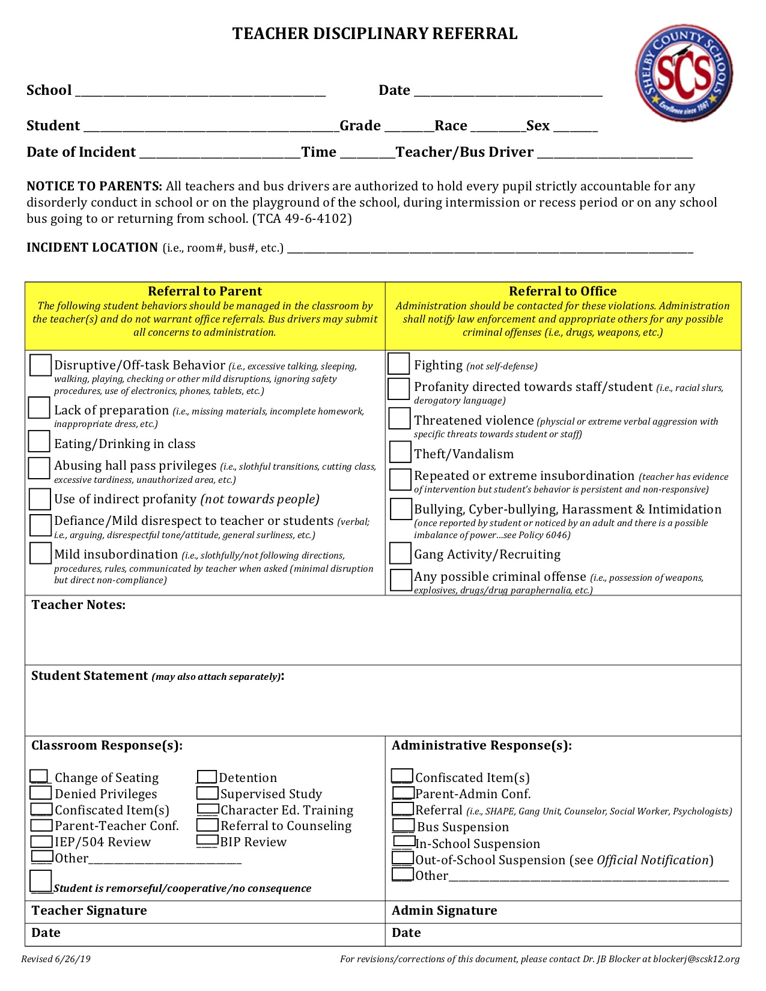

## **Classroom Checklist**

|  |  |
| --- | --- |
| **RTI2-B Core Components** | **Features in the Classroom** |
| **Behavioral**  **Expectations** | * I have the school-wide behavioral expectations posted in my classroom. * My classroom expectations align with the school-wide behavioral   expectations.   * 80% of my students can state the school-wide behavioral   expectations. |
| **Teaching Behavioral Expectations** | * I have taught the school-wide behavioral expectations in my classroom. * I have retaught the school-wide behavioral expectations   throughout the year in my classroom.   * I refer to the school-wide behavioral expectations regularly. * My substitute plans include RTI2-B core components. |
| **Acknowledgement System** | * I use a variety of strategies to give specific positive feedback in   my classroom.   * My students can tell how they receive acknowledgement for   expected behavior.   * I give out acknowledgements that are tied to the school-wide   behavioral expectations in my classroom.   * My students are able to participate in the school-wide   acknowledgement system. |
| **Discipline**  **Process** | * I consider behavioral definitions when determining if problem   behaviors are office-managed or staff-managed.   * I use the Office Discipline Referral form when students engage in   office-managed problem behavior.   * I refer to the school-wide discipline process flowchart when   students engage in problem behavior.   * I provide students an opportunity to get back on track after   engaging in problem behavior. |